Epsom & Ewell F.C.
16
v
Raynes Park Vale
Tuesday, 27th December 2016 - 11.30 a.m.
Good morning and we hope you all had a Happy Christmas! We welcome the players, supporters and officials of Raynes Park Vale, today’s officials and of course, our own regular faces.

We were somewhat fortunate to secure a point at Grand Drive in October with a very late but superb low free kick from Matt Ferdinando although we were worth a point, despite trailing for over 85 minutes in the match. It should also be remembered that we only had one fit player on the bench in Charlie Clark-Gleave that evening and Daniel Rose was thrown in for a full 90 minutes on his debut; something that is very rare here if you don’t make your debut in the first match of the season. It is to be hoped that we have a few more players available to choose from today!

Our last match was at home to Chertsey Town on the Saturday before Christmas when we played well for an hour and led 2-0 but the final thirty minutes were difficult to watch and we just about held on for a 2-1 win. Rob Hendry and Jordan Gallagher both registered a goal and an assist as we moved up to fifth place in the table.

It is as good a time as any to look back at the first half of the season. We have more league goals at this stage of the year than ever with 53 and are handily placed. We can confirm that we are one of five clubs that have applied for promotion and we will continue to do this while the team continue to produce results. It costs the club £120 to do it, but we believe it is money well spent.

As we look forward to the rest of the season, things look quite exciting. We remain well in the hunt for second place, and with significant doubts over whether Hartley Wintney are going to get the work done for them to be promoted, then like last year, second place could be enough to earn promotion. Additionally, we are in the last 16 of the Surrey Senior Cup and the Quarter-Final of the League Cup. The more support that you can give Glyn and the boys, the better.

We also hope to have some big news in the early part of next year regarding a move back to the Borough. In all honesty I had hoped for something by now, but as any long term supporters will know, these things have taken a long time and we must continue to be patient.

Our next match is on Monday 2nd January when we visit Sutton Common Rovers at Sutton United on Monday 2nd January in a match that starts at 12.00 pm. We are then back here on Saturday 7th January when Spelthorne Sports are the visitors and three days later we will welcome Guildford City for our Surrey Senior Cup tie.

Enjoy the game and Happy New Year!

Rich

You can follow us on Facebook: www.facebook.com/epsomandewellfc
Twitter: @EEFCOfficial Instagram at: www.instagram.com/epsomandewellfc
and on Youtube at: www.youtube.com/channel/UCtLrpS0x5OaYUACRT34_zng

Cover photos by Gemma Jarman

- James Taylor scores our first equaliser against Hanworth Villa – eventually!

- Our first goal against Raynes Park on their last visit in August 2015. An own goal!

Cherry Red Records Combined Counties League
Premier Division Table 2016/17
incl Sat 17th December | P | W | D | L | F | A | Pts | GD | H | A
Hartley Wintney | 25 | 21 | 2 | 2 | 83 | 24 | 65 | +59 | 18/3 | 1-3
Westfield | 23 | 15 | 5 | 3 | 53 | 24 | 50 | +29 | 18/2 | 1-2
Hanworth Villa | 26 | 15 | 4 | 7 | 45 | 30 | 49 | +15 | 2-2 | 14/1
Walton & Hersham | 22 | 12 | 8 | 2 | 36 | 18 | 44 | +18 | 4/3 | 1-1
Epsom & Ewell | 22 | 11 | 5 | 6 | 53 | 33 | 38 | +20 | X | X
Horley Town | 22 | 11 | 5 | 6 | 48 | 30 | 38 | +13 | 3-0 | 17/4
Knaphill | 23 | 12 | 2 | 9 | 48 | 44 | 38 | +4 | 4-0 | 8/4
Guildford City | 27 | 11 | 5 | 11 | 56 | 56 | 38 | 0 | 17/1 | 2-0
Bedfont Sports | 21 | 10 | 5 | 6 | 40 | 39 | 35 | +1 | 5-1 | 7/2
Windsor | 26 | 10 | 5 | 11 | 48 | 48 | 35 | 0 | 2-0 | 1-2
Camberley Town | 23 | 10 | 4 | 9 | 45 | 29 | 34 | +16 | 0-0 | 1/4
Colliers Wood United | 24 | 9 | 7 | 8 | 42 | 40 | 34 | +2 | 14/4 | 0-5
North Greenford United | 22 | 9 | 4 | 9 | 48 | 45 | 31 | +3 | 22/4 | 1-2
Spelthorne Sports | 23 | 8 | 5 | 10 | 37 | 40 | 29 | -3 | 7/1 | 25/2
Abbey Rangers | 24 | 8 | 5 | 11 | 35 | 44 | 29 | -9 | 7-1 | 20/2
CB Hounslow United | 22 | 8 | 2 | 12 | 36 | 47 | 26 | -11 | 1-5 | 12/11
Sutton Common Rovers | 22 | 7 | 3 | 11 | 29 | 38 | 24 | -9 | 2-1 | 2/1
Farnham Town | 22 | 7 | 3 | 12 | 35 | 47 | 24 | -12 | 25/3 | 2-1
AFC Hayes | 23 | 6 | 5 | 12 | 37 | 48 | 23 | -11 | 2-2 | 28/1
Chertsey Town | 24 | 5 | 6 | 13 | 28 | 58 | 21 | -30 | 2-1 | 11/2
Raynes Park Vale | 24 | 4 | 5 | 15 | 30 | 52 | 17 | -22 | 27/12 | 1-1
Badshot Lea | 23 | 5 | 2 | 16 | 30 | 63 | 17 | -33 | 4/2 | 4-1
Bedfont & Feltham | 24 | 3 | 5 | 16 | 28 | 70 | 14 | -42 | 21/1 | 9-2

Lucky Day? - 27th December
Played 25 - Won 9 Drawn 2 Lost 14 - For 45 Against 52 - PPG 1.16 - Below Average
Our Club record against Chertsey Town
Played 27 - Won 13 Drawn 6 Lost 8 - For 58 Against 37 - PPG 1.67 - Above Average
Our Largest wins and losses against our opponent
15th December 2012 - Won 6-1 - Combined Counties League (H)
15th September 1990 - Lost 0-2 - Isthmian League Division Two South (A)
27th April 2010 - Lost 0-2 - Combined Counties League (H)
Their Last Visit
31st August 2015 - Won 3-1 - Combined Counties League

First Eleven Appearances 2016/17 - (max 30)
Name | Debut | 2016/17 |  |  |  | Career Totals
 |  | App | Sub | Total | Goals | App | Sub | Total | Goals
CLARK-GLEAVE Charlie | 23/08/2016 | 2 | 2 | 4 | 0 | 2 | 2 | 4 | 0
COOPER-SMITH Daryl | 03/01/2015 | 22 | 1 | 23 | 25 | 52 | 9 | 61 | 45
DEAN Dan | 02/08/2014 | 21 | 2 | 23 | 0 | 89 | 6 | 95 | 2
DEWAR Ali | 29/10/2011 | 0 | 1 | 1 | 0 | 55 | 36 | 91 | 10
EACOTT Michael | 02/08/2014 | 23 | 0 | 23 | 0 | 108 | 1 | 109 | 0
FARRELL Matt | 02/08/2014 | 28 | 0 | 28 | 13 | 114 | 4 | 118 | 31
FERDINANDO Matt | 20/09/2014 | 15 | 5 | 20 | 2 | 68 | 11 | 79 | 16
GALLAGHER Jordan | 07/08/2016 | 16 | 12 | 28 | 8 | 16 | 12 | 28 | 8
GRIFFIN Reisse | 08/08/2015 | 21 | 5 | 26 | 2 | 49 | 11 | 60 | 4
HASTINGS Craig | 08/08/2015 | 20 | 5 | 25 | 1 | 57 | 9 | 66 | 1
HEAGNEY Adam | 16/08/2016 | 18 | 4 | 22 | 0 | 18 | 4 | 22 | 0
HENDRY Rob | 08/08/2015 | 20 | 7 | 27 | 4 | 50 | 18 | 68 | 16
MCKAY Alex | 20/12/2008 | 16 | 3 | 19 | 3 | 124 | 33 | 157 | 11
NEALE Tom* | 13/10/2015 | 6 | 5 | 11 | 7 | 22 | 24 | 46 | 17
NORTH Rhys* | 16/08/2015 | 2 | 2 | 4 | 0 | 19 | 9 | 28 | 1
NWACHUKWU Jason | 01/10/2016 | 5 | 7 | 12 | 0 | 5 | 7 | 12 | 0
PANAYIOTOU Savvas | 03/01/2015 | 23 | 3 | 26 | 4 | 55 | 11 | 66 | 11
PRICE Matt* | 23/08/2016 | 2 | 0 | 2 | 1 | 2 | 0 | 2 | 1
ROBINSON Sam* | 22/10/2011 | 7 | 1 | 8 | 1 | 61 | 6 | 67 | 14
ROSE Daniel | 25/10/2016 | 2 | 5 | 7 | 0 | 2 | 5 | 7 | 0
SALEH Mennar* | 24/09/2016 | 0 | 2 | 2 | 0 | 0 | 2 | 2 | 0
SMITH Matt | 08/08/2009 | 0 | 2 | 2 | 1 | 91 | 45 | 136 | 11
TANTON Matt | 02/08/2014 | 26 | 1 | 27 | 1 | 83 | 5 | 88 | 3
TAYLOR James | 26/08/2013 | 24 | 3 | 27 | 2 | 110 | 15 | 125 | 8
THOMPSON Elliott | 09/02/2016 | 3 | 0 | 3 | 1 | 7 | 9 | 16 | 1
TURPIE Alistair | 31/03/2016 | 7 | 1 | 8 | 0 | 9 | 1 | 10 | 0
WATRET Jack* | 02/08/2016 | 1 | 0 | 1 | 0 | 1 | 0 | 1 | 0
* player has left the club

Latest Results and Fixtures
Combined Counties League – Monday 12th December
Sutton Common Rovers | 1-3 | Abbey Rangers
Surrey Senior Cup Second Round – Tuesday 13th December
Badshot Lea | 1-0 | Farnham Town
Combined Counties League – Tuesday 13th December
Bedfont & Feltham | 2-2 | Chertsey Town
Camberley Town | 2-1 | CB Hounslow United
Epsom & Ewell | 2-2 | Hanworth Villa
Walton & Hersham | 0-0 | Bedfont Sports
Surrey Senior Cup Second Round – Wednesday 14th December
Guildford City | 3-3 | Horley Town
Guildford City win 3-2 on penalties
Combined Counties League – Saturday 17th December
AFC Hayes | 4-1 | Guildford City
Abbey Rangers | 1-1 | Walton & Hersham
Camberley Town | 5-0 | Bedfont & Feltham
CB Hounslow United | 1-2 | Bedfont Sports
Epsom & Ewell | 2-1 | Chertsey Town
Farnham Town | 2-2 | Colliers Wood United
Horley Town | 5-3 | Windsor
Knaphill | 1-4 | Hartley Wintney
North Greenford United | 3-2 | Westfield
Raynes Park Vale | 0-2 | Sutton Common Rovers
Spelthorne Sports | 0-5 | Hanworth Villa
Combined Counties League Cup 3rd Round – Monday 19th December
Sutton Common Rovers | V | Walton & Hersham
Combined Counties League – Tuesday 27th December (11.30 am k.o.)
Abbey Rangers | V | Spelthorne Sports
Bedfont & Feltham | V | CB Hounslow United
Bedfont Sports | 12.00pm | North Greenford United
Camberley Town | V | Farnham Town
Chertsey Town | V | Horley Town
Latest Results and Fixtures
Combined Counties League – Tuesday 27th December (11.30 am k.o.)
Epsom & Ewell | V | Raynes Park Vale
Hanworth Villa | 1.00pm | AFC Hayes
Hartley Wintney | V | Badshot Lea
Walton & Hersham | V | Westfield
Windsor | V | Knaphill
Combined Counties League – Wednesday 28th December
Colliers Wood United | V | Sutton Common Rovers
Combined Counties League – Monday 2nd January (11.30 am k.o.)
AFC Hayes | V | Windsor
Badshot Lea | V | Camberley Town
Bedfont & Feltham | V | Hanworth Villa
Guildford City | V | Abbey Rangers
Hartley Wintney | V | Farnham Town
Horley Town | V | Raynes Park Vale
North Greenford United | V | CB Hounslow United
Spelthorne Sports | V | Bedfont Sports
Sutton Common Rovers | 12.00 | Epsom & Ewell
Walton & Hersham | V | Knaphill
Westfield | V | Chertsey Town
Combined Counties League – Saturday 7th January
Abbey Rangers | V | Bedfont & Feltham
Bedfont Sports | V | Hartley Wintney
Camberley Town | V | Walton & Hersham
CB Hounslow United | V | Horley Town
Colliers Wood United | V | AFC Hayes
Epsom & Ewell | V | Spelthorne Sports
Farnham Town | V | North Greenford United
Hanworth Villa | V | Westfield
Knaphill | V | Badshot Lea
Raynes Park Vale | V | Guildford City
Surrey Senior Cup Third Round – Tuesday 10th January
Epsom & Ewell | V | Guildford City

From behind the goal
Epsom & Ewell 2-1 Chertsey Town
Combined Counties League - Premier Division - Saturday 17th December 2016

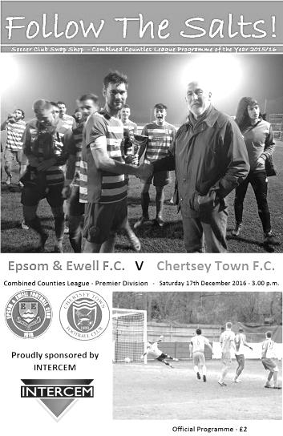
Salts fall over the line

Three weeks prior to this match we dominated AFC Hayes in a League contest for 80 minutes only to concede twice and drop points in a 2-2 draw. This week the circumstances were similar, but fortunately we were able to hold on despite a nervy ending to secure the three points on offer.

Michael Eacott returned to the starting eleven while Dan Dean moved back into the defence. Agi Panayiotou came into the holding midfield role while James Taylor moved to right back, placing Adam Heagney on the bench. Up front Jason Nwachukwu started in place of Daryl Cooper-Smith who was rested, while on the right Reisse Griffin came in for Matt Ferdinando who started on the bench.

The opening exchanges on a very foggy day at Chipstead were fairly even with both teams having spells of possession but without causing real danger. We had one attempt on goal as early as the fourth minute from Jordan Gallagher but his free kick from wide out was punched to safety by visiting keeper Chico Ramos. We began to dictate more of the play as the half went on but with an annoying tendency to fail to clear the first man with our delivery. Sometimes being more direct can be more successful and both sides had an attempt on target, although both were saved comfortably.

Matt Tanton was the next player to find a bit of space and he ventured forwards and struck powerfully from outside the penalty area but the ball went just beyond the far post. This was followed by a good run and shot from Jason Nwachukwu but it was clear that he was already struggling with injury and he was replaced by Ferdinando after just 25 minutes. He slotted in to Nwachukwu's role just behind Rob Hendry and appeared comfortable in his new position while he was there.

It was the 27th minute before a dangerous cross was produced but Tanton's left flank delivery was a couple of inches ahead of the diving Hendry who was only able to feather the ball as it went past him. Pressure was building though and Ferdinando got through on the left but was on his weaker foot and the danger was cleared. However, it soon came back in and Gallagher saw his shot blocked behind him to Matt Farrell who tried to curl the ball into the top corner from the edge of the area but couldn't keep the ball down.

However, Farrell was responsible for setting us up for the opening goal in the 38th minute. We pressed the visitors back and the clearance from Ramos was intercepted by Farrell who set up Griffin for a deep cross. At the far post Gallagher attempted to take the ball in stride

when maybe he should have shot at goal but he miscontrolled it. However, he had also wrong footed his defender in the process and was able to get to the loose ball first, although Ramos was unfortunate here as he was out quickly to block the incoming shot which looped up off him and fell kindly for Hendry to head into the empty net from close range.

Hendry nearly scored a spectacular second soon after the restart as a dipping ball was volleyed at goal from 20 yards but Ramos was just able to keep the ball out. However, a foul on Griffin out on the right gave Hendry the chance to deliver and with our big guys waiting at the back he delivered a near post ball that Gallagher flicked into the net with the outside of his foot in the 53rd minute.

Surely there was no way back for Chertsey. They had created little of threat to this point and scoring twice seemed highly unlikely. Having said that, they gave it a really good try. Their two full backs Ben Geraughty and Steve Newman, a former Salt, were both excellent in defence throughout and now started to push forward a lot more. Newman blotted his copy book slightly with a rather farcical dive that earned him a yellow card and Craig Hastings one too for taking him to task over it, but they were helping to change the balance of the game and in the 64th minute the visitors pulled a goal back when a corner appeared to be flicked on and was met by a close range header from the substitute Joel Thompson.

Maybe still aware of the collapse three weeks previously we struggled to get out of our half for much of the next twenty minutes as we were penned back. Shots flew across our goal as we struggled to get any foothold for a while. Daniel Rose came on for Griffin to bolster the centre of the park and we did create a chance moments later when a ball between defence and keeper was only half cleared and Hendry drilled his shot low from the edge of the area but the ball was blocked by the legs of Ramos. As time ticked on we made a last ditch clearance at the far post but as the game went into injury time we somehow got caught upfield, allowing them to break through on goal. Only Dan Dean's saving challenge around the edge of the box kept us ahead. He then made another important challenge in the 95th minute, although this one wasn't quite as legal and picked up a yellow card but without such a challenge we would have been in serious trouble.

Finally after just over six minutes of injury time, despite the complete absence of any injuries, we were able to celebrate the three points. It had been a worrying experience for supporters particularly but looking back at the final twenty five minutes as a whole, Michael Eacott only had one real shot to save, a low effort at his near post in the 92nd minute, so the defence deserve some credit here. Our midfield need to help them out more though and it looks to me as though we are missing the steadying influence of Alex McKay presently. Overall though and considering that we didn't play our leading scorer and suffered injury to another striker so early in the game, this was a match that could have gone against us, so it is quite pleasing to see us up to fifth at Christmas and with 53 goals scored, a new club record for this stage of the year.

Epsom and Ewell: Michael Eacott, James Taylor, Matt Tanton, Craig Hastings,
Dan Dean (c), Savvas 'Agi' Panayiotou, Jordan Gallagher, Matt Farrell,
Rob Hendry, Jason Nwachukwu, Reisse Griffin

Subs: Matt Ferdinando for Nwachukwu (25), Adam Heagney for Hastings (57),
Daniel Rose for Griffin (77)

Raynes Park Vale F.C. – History
Raynes Park Vale FC was founded in 1995 from the merger of two clubs, Raynes Park FC and Malden Vale FC.

Raynes Park FC was founded in 1964, taking over from the Southern Railway Football Section. These details were confirmed by our current President, Robert Hallett Snr. who was instrumental in the formation of the club.

From these humble beginnings, the club ran five senior teams on Saturdays. The 1st & 2nd XI's played out of the Surrey Premier League. The 3rd team played in the Surrey South Eastern Counties League, whilst the 4th & 5th teams played in the Kingston & District. Raynes Park also had an over 35's team who played their matches on Sundays and also ran teams from under 14's to under 18's.

Malden Vale FC was founded in 1967 by the then Chairman Stephen Pearce. They spent their first decade of existence playing in the North Surrey Youth League, the Sunday Sportsman League, South Thameside League & the Surrey Combination League. Malden Vale won a total of 37 honours at junior & intermediate level.

Malden Vale gained senior status in the 1977-78 season and were duly elected to the Surrey Senior League. The following season the league changed its name to the Home Counties League. After one season in the newly named league, Malden Vale applied to join the London Spartan League. They were accepted into the Premier Division. Ten seasons later in the 1988-89 season Malden Vale finished runners-up to BAE Weybridge in the Dan Air League and were promoted to the Diadora League Division 2 South. All of the club's members worked extremely hard to gain C Grade status for entry into the league.

The club survived for 5 seasons in the Diadora Isthmian League. At the end of the successful 1993-94 season, managers Mick Brown & Ged Murphy left the club to join Hendon. Unfortunately many of the players followed them and Malden Vale finished bottom of the table the following season.

On Saturday 18th August 1995, after two years in the planning, the newly formed Raynes Park Vale FC played its first match in the Combined Counties League.

In 2013 the club was granted £50,000 from the Budweiser Club Futures Programme, by the FA, towards the cost of ground and club/function room upgrade, which was completed in 2014.

In 2014/15 they finished in 15th position after a strong start, which also included a run to the second qualifying round of the F.A. Cup, losing narrowly at Ryman Premier League team Billericay Town.

My Club Betting
We can now announce that Epsom & Ewell F.C.
now have our own betting site!

If you like to have a bet, this is for you.

In conjunction with MyClubBetting.com you can now access all the regular markets that you might do regularly with just a click on our website.

But why would you do this? Many of you already might have apps that you currently use.

The main reason is that you would benefit the club by doing so, but at the same time would not lose out yourselves. Their odds are at least comparable and in many cases better than the other bookmakers out there and by registering with us, the club would make 20% of any cumulative losses and with enough usage, we would qualify for other fairly substantial club benefits.

If you win the bet that you place, that is fantastic news, but whichever company you use currently would keep 100% of any losses. This way our club can receive a nice lump sum in the event that you are unlucky.

For example. If we have 20 people signed up and they lost £25 over the month each, our club would receive £100 back out of the £500 lost.

So just visit: https://eefc.myclubbetting.co.uk/ and join the club!

Club Records - 27th December
Date | Day | Competition |  | Opponents |  | Scorers
27/12/24 | Sat | Surrey Senior League | H | Dorking | 0-1
27/12/26 | Mon | Surrey Senior League | A | Aldershot Traction | 4-1 | R.Marlow (2), A.Mackesy, R.Coleman
27/12/30 | Sat | Surrey Senior Cup 4q replay | H | Egham | 3-2+ | E.Matkin (2), T.Jones
27/12/32 | Tue | London League | H | Chelmsford | 3-3 | B.Williams, L.Marlow, G.Mackesy (pen)
27/12/37 | Mon | Friendly | H | Wandsworth United | 5-2 | T.Rochester (3), J.Jones, B.Beglan
27/12/47 | Sat | Friendly | H | Dorking | 1-4 | T.Rochester
27/12/48 | Mon | Friendly | H | Guildford | 1-0 | J.Emblem
27/12/49 | Tue | Corinthian League | H | Carshalton Athletic | 1-3 | E.Watkins (pen)
27/12/54 | Mon | Corinthian League | H | Carshalton Athletic | 1-2 | B.Musto
27/12/55 | Tue | Corinthian League | H | Carshalton Athletic | 1-4 | J.Sorensen
27/12/58 | Sat | Corinthian League | A | Horsham | 1-5 | R.Carter
27/12/69 | Sat | Athenian League 2 | H | Eastbourne | 1-4 | K.Gregory
27/12/71 | Mon | Athenian League 2 | A | Worthing | 0-2
27/12/75 | Sat | Athenian League 2 | A | Edgware | 0-1
27/12/82 | Mon | Isthmian League 1 | H | Hampton | 1-2 | M.Jonas
27/12/83 | Tue | Isthmian League 1 | A | Walton & Hersham | 2-3 | S.Milton, S.Hill
27/12/86 | Sat | Isthmian League 1 | H | Oxford City | 0-1
27/12/88 | Tue | Isthmian League 2s | H | Banstead Athletic | 3-0 | B.Perkins, Williams, C.Hadingham
27/12/93 | Mon | Isthmian League 3 | A | Horsham | 5-2 | N.Webb (3), P.Meredith, R.Dymond
27/12/97 | Sat | Isthmian League 3 | H | Croydon Athletic | 3-1 | K.Webb (2), A.Nimmo
27/12/99 | Mon | Isthmian League 3 | H | Egham Town | 0-0
27/12/03 | Sat | Isthmian League 1s | A | Banstead Athletic | 1-4 | S.Hatton
27/12/04 | Mon | Isthmian League 2 | A | Chertsey Town | 2-5 | J.Buckley, R.Shoefield
27/12/08 | Sat | Combined Counties  Premier Division | A | Banstead Athletic | 5-0 | K.Hough (2), S.Sinclair (2), L.White
27/12/11 | Tue | Combined Counties  Premier Division | A | Banstead Athletic | 1-0 | R.White
Historical Decades
Date | Day | Competition |  | Opponents |  | Scorers
27/12/26 | Mon | Surrey Senior League | A | Aldershot Traction | 4-1 | R.Marlow (2), A.Mackesy, R.Coleman
26/12/36 | Sat | Friendly | H | Combined L.C.C.Hospitals | 3-3 | H.Pullen (pen), G.Collins (2)
26/12/46 | Thur | Friendly | H | Crawley | 6-0 | G.Brogdale (4) + 2 others
26/12/56 | Wed | Corinthian League | H | Dorking | 9-0 | J.Bangs (4), D.Hermitage (3), R.Colfar, B.Jenkins (pen)
31/12/66 | Sat | Athenian League 2 | A | Edmonton | 1-2 | T.Williams
27/12/86 | Sat | Isthmian League 1 | H | Oxford City | 0-1
26/12/96 | Thur | Isthmian League 3 | A | Lewes | 5-2 | M.Jones, T.Hoy, P.Meredith, S.Miller, o.g.
26/12/06 | Tue | Combined Counties  Premier Division | A | Banstead Athletic | 1-1 | P.Solomon

History Corner – 27th December
92 years ago today we hosted Dorking in a Surrey Senior League match at the Horton Hospital Grounds. We had met Dorking for the first ever time on the Boxing Day, winning 3-2 at their old ground in Pixham Lane, but this match would be completely affected by driving wind and rain, so severe that even the reporter in the local paper didn’t venture from the changing room / pavilion structure across the field! There was no cover at the ground and clearly a very small attendance too but a very late goal for a non-existent penalty for the visitors handed us our first ever defeat at the ground. Not bad really, seeing as we had been there for two and a half seasons by then. The following season we would move to West Street.

79 years ago today Tommy Rochester scored a hat trick for us in our 5-2 friendly win over Wandsworth United, a fellow London League team playing at the Greyhound Stadium in Wandsworth, which is now covered by a Shopping Centre. This game took place at West Street however.

70 years ago this week Gordon Brogdale scored four goals in a 6-0 friendly match over Crawley at West Street. Our opponents added the Town to their name a few years later and have gone on to do quite well for themselves in recent seasons!

60 years ago today we had our first League meeting with Dorking since the Twenties as they had recently joined the Corinthian League. We were in fine form that season and chasing the title, so a home win was expected, but even the home supporters weren’t expecting 9-0! Johnny Bangs scored four times on his way to 53 goals for the season while Dave Hermitage also scored a hat trick. Ray Colfar and Brian Jenkins made up the scorers, all four of whom would go on to have massive success at a higher level, Hermitage with Sutton United, Banhs with Redhill, Jenkins with Walton & Hersham and Colfar with Crystal Palace and Guildford City. (see programme)

23 years ago today we visited the much missed Queen Street, home of Horsham, and we battered them in an Isthmian League match by five goals to two. They couldn’t handle the pace of Nigel Webb who scored three times, with Ricky Dymond and Paul Meredith completing the scoring. Meredith is a diving instructor in Thailand these days where he has been for a number of years now.
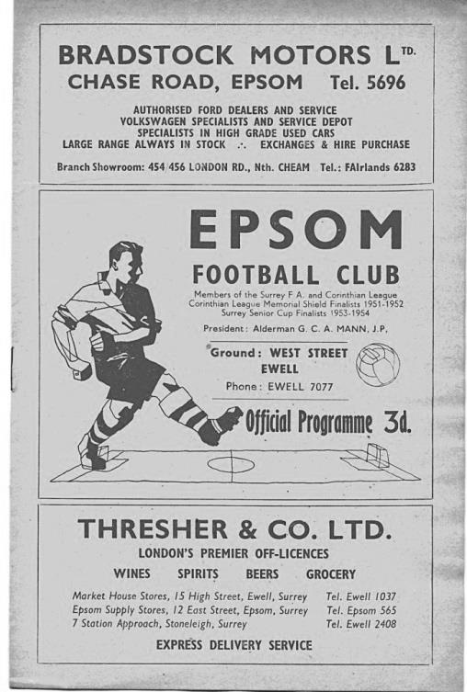
20 years ago this week we defeated Lewes 5-2 in a League match at the Dripping Pan. The highlight of this match was a flowing move containing a number of passes and finished off with a clinical strike from fit again Stuart Miller. A great goal!

8 years ago today we handed our landlords Banstead Athletic a 5-0 thrashing in an “away” fixture at Merland Rise with goals from Kyle Hough (2), Leon White and Shane Sinclair (2). Sinclair had been signed from Horley Town after impressing against us and this brace in his second match indicated promise but it didn’t work out at all and he left soon after.

Centre page for results

Centre page for results

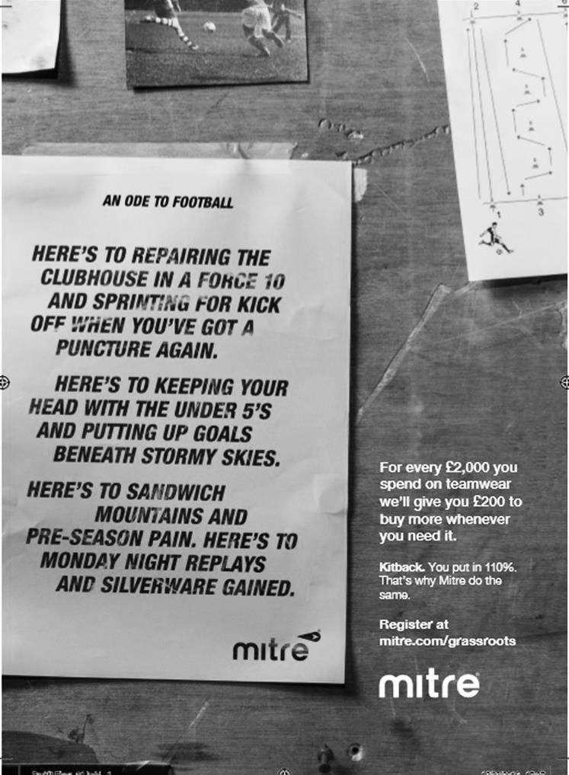

Surrey Senior Cup
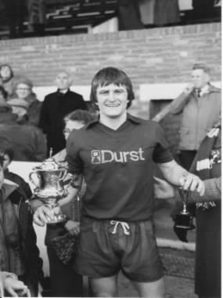
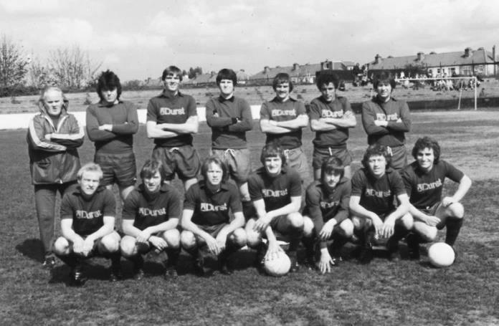
Second Round
Met Police | 0-0 | Kingstonian
Match played at Met Police F.C. – Kingstonian won 7-6 on penalties
Ashford Town (Mx) | 0-1 | Knaphill
Woking | 4-0 | Walton Casuals
Whyteleafe | 5-1 | Colliers Wood United
Guildford City | 3-3 | Horley Town
Guildford City won 3-2 on penalties
Egham Town | 3-0 | Corinthian Casuals
Godalming Town | 0-1 | Merstham
Molesey | 0-1 | Leatherhead
Raynes Park Vale | 1-1 | Sutton United
Raynes Park Vale won 4-3 on penalties
Sutton Common Rovers | 5-1 | Camberley Town
Dorking Wanderers | 2-1 | South Park
Badshot Lea | 1-0 | Farnham Town
Walton & Hersham | 3-0 | Croydon
Carshalton Athletic | 0-2 | Tooting & Mitcham United
Chertsey Town | 2-1 | Abbey Rangers
Epsom & Ewell | 3-0 | Chipstead
Third Round
Whyteleafe | V | Egham Town
Badshot Lea | V | Raynes Park Vale
Epsom & Ewell | V | Guildford City
Dorking Wanderers | V | Sutton Common Rovers
Kingstonian | V | Chertsey Town
Woking | V | Leatherhead
Merstham | V | Walton & Hersham
Tooting & Mitcham United | V | Knaphill

EL Records Premier Challenge Cup
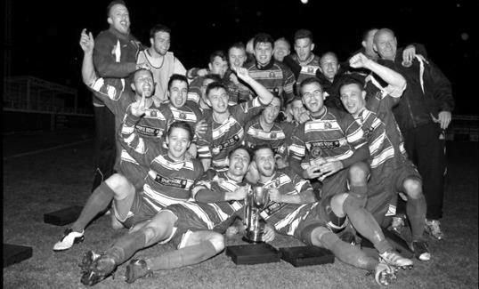
Second Round
Hanworth Villa | 2-4+ | Epsom and Ewell
AFC Hayes | 3-4 | Balham
Epsom Athletic | 1-5 | Windsor
Sutton Common Rovers | 2-1 | Bedfont Sports
Raynes Park Vale | 2-0 | Colliers Wood United
Frimley Green | 1-2 | Banstead Athletic
Westfield | 8-4+ | Redhill
Staines Lammas | 0-1 | Farnham Town
Worcester Park | 8-1 | Cove
Badshot Lea | 0-5 | Guildford City
Chertsey Town | 1-2 | Camberley Town
Cobham | 1-3 | Chessington & Hook United
Hartley Wintney | 4-0 | AC London
Horley Town | 2-2+ 5-4p | Sheerwater
Walton & Hersham | 5-1 | Eversley & California
Ash United | 2-0 | Farleigh Rovers
Third Round
Banstead Athletic | 4-4+ 3-4p | Westfield
Sutton Common Rovers | 19/12 | Walton & Hersham
Farnham Town | 0-4 | Camberley Town
Ash United | 0-2 | Windsor
Raynes Park Vale | 2-1 | Hartley Wintney
Guildford City | 2-1 | Balham
Horley Town | 2-0 | Chessington & Hook United
Worcester Park | 3-6 | Epsom & Ewell
Quarter Finals
Windsor | 24/1 | Horley Town
Guildford City | 25/1 | Raynes Park Vale
Westfield | 17/1 | Camberley Town
Sutton Common Rovers /  Walton & Hersham | V | Epsom & Ewell

Combined Counties League Premier Division Opponents
All-time Records
incl Saturday 17th  December | P | W | D | L | F | A | PPG | GD | Best  Win | Worst  Loss
Bedfont & Feltham | 1 | 1 | 0 | 0 | 9 | 2 | 3.00 | +7 | 9-2 | X
Spelthorne Sports* | 5 | 4 | 1 | 0 | 15 | 6 | 2.60 | +9 | 6-2 | X
Sutton Common Rovers | 11 | 9 | 1 | 1 | 29 | 13 | 2.55 | +16 | 4-0 | 1-4
Horley Town | 29 | 20 | 5 | 4 | 65 | 30 | 2.24 | +35 | 6-0 | 1-3
Colliers Wood United | 22 | 14 | 2 | 6 | 45 | 33 | 2.00 | +12 | 4-0 | 0-5
Bedfont Sports | 10 | 6 | 2 | 2 | 18 | 11 | 2.00 | +7 | 5-1 | 0-4
Abbey Rangers | 3 | 2 | 0 | 1 | 10 | 4 | 2.00 | +6 | 7-1 | 2-3
Westfield | 19 | 11 | 3 | 5 | 40 | 31 | 1.89 | +9 | 6-1 | 0-4
Farnham Town | 14 | 8 | 2 | 4 | 25 | 23 | 1.86 | +2 | 3-1 | 1-4
Knaphill | 7 | 4 | 1 | 2 | 15 | 8 | 1.86 | +7 | 4-0 | 1-2
Guildford City | 17 | 10 | 1 | 6 | 34 | 22 | 1.82 | +12 | 5-1 | 1-5
Hanworth Villa | 16 | 8 | 4 | 4 | 38 | 26 | 1.75 | +12 | 5-0 | 1-4
Raynes Park Vale | 27 | 13 | 6 | 8 | 58 | 37 | 1.67 | +21 | 6-1 | 0-2
Badshot Lea | 18 | 8 | 3 | 7 | 35 | 34 | 1.67 | +1 | 4-1 | 0-4
Walton & Hersham | 50 | 24 | 10 | 16 | 101 | 97 | 1.64 | +4 | 6-0 | 0-8
Camberley Town* | 89 | 38 | 22 | 28 | 158 | 123 | 1.52 | +35 | 9-1 | 0-4
Hartley Wintney | 11 | 4 | 3 | 4 | 26 | 20 | 1.36 | +6 | 5-0 | 2-4
Windsor | 49 | 19 | 12 | 18 | 90 | 90 | 1.41 | 0 | 4-0 | 0-6
Chertsey Town | 48 | 18 | 5 | 25 | 72 | 87 | 1.23 | -15 | 3-0 | 0-7
AFC Hayes | 9 | 2 | 3 | 4 | 18 | 17 | 1.00 | +1 | 7-0 | 0-3
North Greenford United | 11 | 3 | 2 | 6 | 15 | 20 | 1.00 | -5 | 3-0 | 1-4
CB Hounslow United | 2 | 0 | 0 | 2 | 2 | 7 | 0.00 | -5 | X | 1-5
* includes one abandoned match v Camberley and one loss on penalties v Spelthorne

CCL Premier Division Club Directory
ABBEY RANGERS Telephone: 01932-422962 - Ground: Addlestone Moor, Addlestone, Surrey KT15 2QH - Colours: Black & White Stripes/Black/Black

A.F.C. HAYES Telephone: 0208-845-0110 - Ground: Farm Park, Kingshill Avenue, Hayes, Middx. UB4 8DD - Colours: Blue and White Stripes/Blue/Blue

BADSHOT LEA Telephone: 01252-320385 - Ground: Ash United FC, Shawfield Stadium, Youngs Drive, Shawfields Road, Ash, Hampshire. GU12 6RE - Colours: Claret/White/Claret

BEDFONT & FELTHAM Telephone: 0208 890 7264 - Ground: The Orchard, Hatton Road, Bedfont, Middx TW14 9QT - Colours: Yellow & Blue/Blue/Blue

BEDFONT SPORTS Telephone: 0208-831-9067 - Ground: Bedfont Sports Club, Hatton Road, Bedfont, Middx TW14 8JA - Colours: Red & Black Hoops/Black/Red & Black Hoops

CAMBERLEY TOWN Telephone: 01276-65392 - Ground: Krooner Park, Wilton Road, Camberley, Surrey. GU15 2QW - Colours: Red & White Stripes/Blue/Red

CB HOUNSLOW UNITED Telephone: 0208 890 7264 - Ground: The Orchard, Hatton Road, Bedfont, Middx TW14 9QT - Colours: Green/Black/Green

CHERTSEY TOWN Telephone: 01932-561774 - Ground: Alwyns Lane, Chertsey, Surrey. KT16 9DW - Colours: Royal Blue & White Stripes/Royal Blue/Royal Blue

COLLIERS WOOD UNITED Telephone: 0208-942 8062 - Ground: Wibbandune Sports Ground, Robin Hood Way, Wimbledon. SW20 0AA - Colours: Blue & Black Stripes/Black/Black
EPSOM & EWELL Telephone: 01737-553250 - Ground: Chipstead FC, High Road, Chipstead, Surrey. CR5 3SF - Colours: Royal Blue & White Hoops/Royal Blue/Royal Blue

FARNHAM TOWN Telephone: 01252-715305 Ground: Memorial Ground, Babbs Mead, West Street, Farnham, Surrey. GU9 7DY Colours: - Claret & Sky Blue /White/ Claret & Sky Blue

GUILDFORD CITY Telephone: 01483-443322 - Ground: The Spectrum, Parkway, Guildford, Surrey. GU1 1UP - Colours: Red & White Stripes/Black/Black

HANWORTH VILLA Telephone: 0208-831-9391 - Ground: Rectory Meadows, Park Road, off Hounslow Road, Hanworth, Middlesex. TW13 6PN - Colours: Red & White Stripes/Black/Black

HARTLEY WINTNEY Telephone: 01252-843586 - Ground: Memorial Playing Fields, Green Lane, Hartley Wintney, Hants RG27 8DL - Colours: Orange & Black/ Orange /Orange

HORLEY TOWN Telephone: 01293-822000 - Ground: The New Defence, Anderson Way, Court Lodge Road, Horley, Surrey. RH6 8SP - Colours: Claret & Sky Blue/Claret/Claret

KNAPHILL Telephone: 01483-475150 - Ground: Brookwood Country Park, Redding Way, Lower Guildford Road, Knaphill, Surrey. GU21 2AY - Colours: Red/Black/Red

NORTH GREENFORD UNITED Telephone: 0208 422 8923 - Ground: Berkeley Fields, Berkeley Avenue, Greenford, Middx UB6 0NX - Colours: Royal Blue & White/Royal Blue/Royal Blue

SUTTON COMMON ROVERS Telephone: 01932-866386 - Ground: Sutton United FC, Gander Green Lane, Sutton, Surrey SM1 2EY - Colours: Yellow/Black/Black

RAYNES PARK VALE Telephone: 020-8540-8843 - Ground: Prince Georges Playing Field, Grand Drive, Raynes Park, London. SW20 9NB - Colours: Blue/Blue/Red

SPELTHORNE SPORTS Telephone: 01932-961055 - Ground: Spelthorne Sports Club, Staines Road, Ashford Common, Ashford, Middx. TW15 1RY - Colours: Light & Dark Blue/Dark Blue/Light Blue

WALTON & HERSHAM Telephone: 01932 245263 - Ground: Stompond Lane, Walton on Thames, Surrey KT12 1HF - Colours: Red/Red/Red

WESTFIELD Telephone: 01483-771106 - Ground: Woking Park, Kingfield Road, Woking, Surrey. GU22 9BA - Colours: Yellow/Black/Black

WINDSOR Telephone: 01753-860656 - Ground: Stag Meadow, St Leonards Road, Windsor, Berks SL4 3DR - Colours: Red/Red/Red

Player Sponsorship
Here is the current list for the 2016/17 season showing all of our players and Management that are available for sponsorship.

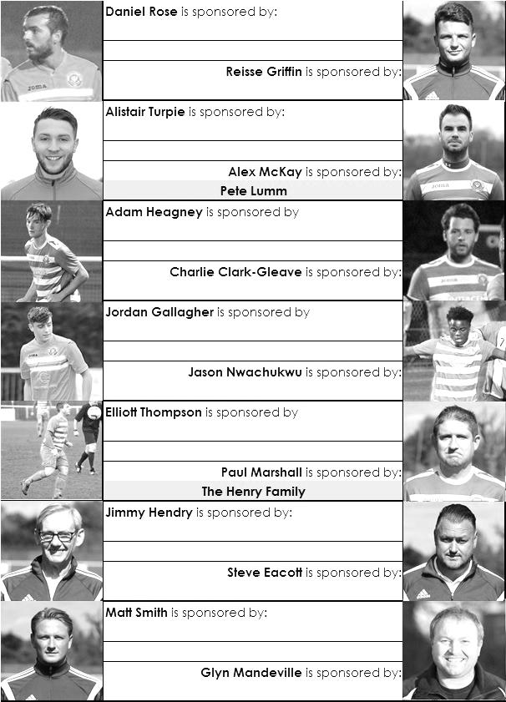

Sponsorship costs just £40 and it is easy to do. Just select a player who has not been previously sponsored and let a Committee Member know that you would like to sponsor them. Beware though. Until we have received the money it is possible for someone to jump in front of you, so don’t delay, sponsor today!
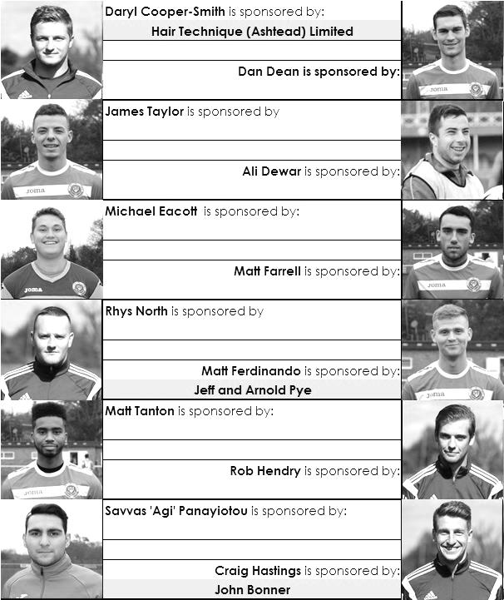

Match and Ball Sponsorships – 2016/17
Opponent | Date | Match Sponsor | Ball Sponsor
Gravesham Borough | 07/08/16 | Club President - Stella Lamont
Gravesham Borough | 07/08/16 | Relocation Committee Member - Mike Lovett
CB Hounslow United | 16/08/16 | EEFC Management Committee
Abbey Rangers | 23/08/16 | Steve & Geoff Dyke
Horley Town (11.30am) | 29/08/16 | In Memory of Chris Henry
Abbey Rangers (LC) | 06/09/16 | Paul Merritt
Camberley Town | 10/09/16 | Building Shop Ltd
Knaphill | 24/09/16 | EEFC Holding Company Director – Pete Lumm
Bridon Ropes (FAV) | 22/10/16 | George and Joseph Saunders
Sutton Common Rovers | 08/11/15 | Alex McKay Senior
Abbey Rangers (FAV) | 13/11/16 | EEFC Holding Company Director – Dave Ellins
Windsor | 15/11/16 | In Memory of Wally Dyke
Bedfont Sports | 19/11/16 | John Bonner
AFC Hayes | 26/11/16 | Jack Jarman
Chipstead (SSC / DWT) | 06/12/16 | Trevor Stotten
Hanworth Villa | 13/12/16 | Roger and Carol Farrell
Chertsey Town | 17/12/16
Raynes Park Vale (11.30am) | 27/12/16 | In memory of Dave and Liz Marshall
Spelthorne Sports | 07/01/17 | Building Shop Ltd
Guildford City (SSC) | 10/01/17
Guildford City | 17/01/17
Bedfont & Feltham | 21/01/17 | Programme Editor - Richard Lambert
Badshot Lea | 04/02/17
Westfield | 18/02/17
Walton & Hersham | 04/03/17
Hartley Wintney | 18/03/17
Farnham Town | 25/03/17
Colliers Wood United (1pm) | 14/04/17 | Good Friday match – make a note!
North Greenford United | 22/04/17 | Club President - Stella Lamont
For League, League Cup and Surrey Senior Cup Matches:
Match sponsorship - £40.00 Match ball sponsorship - £25.00. Combined £55.00.
For F.A. Cup and F.A. Vase matches:
Match sponsorship - £50.00 Match ball sponsorship - £30.00. Combined £65.00.

Sponsorship includes: (x2 for match, x3 for match and ball)

Admission, programmes, hospitality and advertising and mascot for the day (if required).
If you are interested, just speak to a Committee Member, or drop me an email at: richard.c.lambert@gmail.com

We also thank our Kit Sponsors INTERCEM

Salts Super Six Predictor
The Salts Super Six Predictor is live again for today’s match and the tickets are on sale at today’s game to the left of the gate.

The jackpot was won recently but is already increasing and is up to £103.

The competition is easy to play! To win, you simply need to predict the results of six matches correctly from the three options, fill in the form and make sure it is back with our seller before the deadline on the ticket. The latest fixtures are shown below.

If you are a club regular, you just need to place your name on the sheet, although if you aren’t, then we’ll need a contact number from you too. We will announce any winners on the website within three working days, so don’t worry, we won’t miss you!

Please note that if there is more than one winner, the prize pot would be shared between the winners. All you need to do now is have a go, as many times as you like!

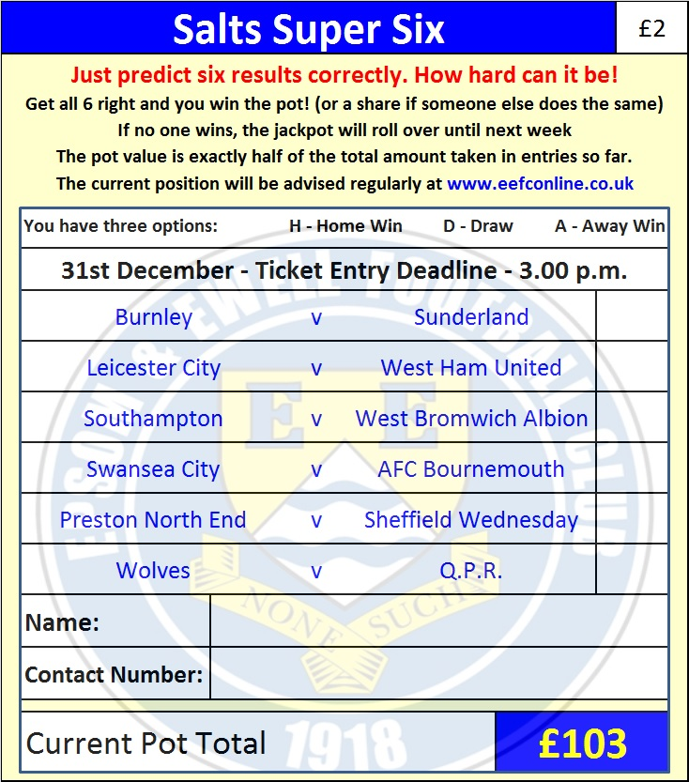
Good luck!

Combined Counties League – Premier Division
Tuesday, 27th December 2016 - Kick-off 11.30 a.m.

Epsom and Ewell  (Royal Blue & White hoops) | V |  | Raynes Park Vale  (All Yellow)
Squad | NUMBERS |  | Squad
Michael Eacott |  |  | Alex Sykes
Adam Heagney |  |  | Ed Cornwell
Matt Tanton |  |  | Jack Williamson
James Taylor |  |  | Anthony Moulds
Craig Hastings |  |  | Shane McEntaggert
© Dan Dean |  |  | Marcus Dowdeswell
Jordan Gallagher |  |  | Naseem Youngsam
Matt Farrell |  |  | Chris Spencer
Rob Hendry |  |  | Jerome Smart
Savvas ‘Agi’ Panayiotou |  |  | Eion Fraser
Matt Ferdinando |  |  | Thomas Bentley
Jason Nwachukwu |  |  | Reece Turner
Reisse Griffin |  |  | Malaki Thomas
Daryl Cooper-Smith |  |  | Dan Amaju
Alex McKay |  |  | Viktor Skillz
Daniel Rose |  |  | Liam Williams
Alistair Turpie |  |  | Calum Forbes
Charlie Clark-Gleave |  |  | James Norton
Matt Smith |  |  | Tom Harland-Goddard
Glyn Mandeville | MANAGER |  | Gavin Bolger
Matt Smith | ASSISTANT |  | Paul Bentley
Steve Eacott / Alex McKay /  Jimmy Hendry | COACHES / PHYSIO |  | Peter Heyne / Jeff Clayton
REFEREE: M.Edwards
ASSISTANTS: M.Stevens, K.Parker
Today’s Match and Match Ball are kindly sponsored
In memory of Dave and Liz Marshall

OUR NEXT VISITORS TO HIGH ROAD
Spelthorne Sports
Combined Counties League – Premier Division
Saturday 7th January 2017 – 15.00 p.m.

